A Report

on

AI-Assisted Quantum Simulation & Modelling with Salesforce Agentforce

carried out as part of the course Project Based Learning- 2
Submitted by

Shriya Desai

2427030171

IV Semester

in partial fulfilment for the award of the degree

of

BACHELOR OF TECHNOLOGY

In

Computer Science & Engineering



Department of Computer Science & Engineering,
School of Computer Science and Engineering,
Manipal University Jaipur,
Jan-May 2026

A Report

on

AI-Assisted Quantum Simulation & Modelling with Salesforce Agentforce

carried out as part of the course Project Based Learning-2
Submitted by

Shriya Desai

2427030171

IV Semester

in partial fulfilment for the award of the degree

of

BACHELOR OF TECHNOLOGY

In

Computer Science & Engineering

Under the Guidance of :

Guide Name : …Dr. Ankit Shrivastava……

Guide Signature(with date) : ………………………………………

Acknowledgement

This project would not have been completed without the help, support, comments, advice, cooperation and coordination of various people. However, it is impossible to thank everyone individually; I am hereby making a humble effort to thank some of them.

I acknowledge and express my deepest sense of gratitude to my internal supervisor Dr. Ankit Shrivastava for his/her constant support, guidance, and continuous engagement. I highly appreciate his technical comments, suggestions, and criticism during the progress of this project titles “AI-Assisted Quantum Simulation and Modelling with Salesforce Agentforce”.

I owe my profound gratitude to Dr. Neha Chaudhary , Head, Department of CSE, for her valuable guidance and for facilitating me during my work. I am also very grateful to all the faculty members and staff for their precious support and cooperation during the development of this project.

Finally, I extend my heartfelt appreciation to my classmates for their help and encouragement.

Shriya Desai

2427030171



Department of Computer Science and Engineering
School of Computer Science and Engineering

Date: _13/4/26_

CERTIFICATE

This is to certify that the project entitled “AI-Assisted Quantum Simulation & Modelling with Salesforce Agentforce” is a bonafide work carried out as PBL-2 End Term Assessment in partial fulfillment for the award of the degree of Bachelor of Technology in Computer Science and Engineering, by Shriya Desai bearing registration number 2427030171, during the academic semester IV of year 2025-2026.

Place: Manipal University Jaipur, Jaipur

Name of the project guide: _Dr. Ankit Shrivastava_

Signature of the project guide: ______________________

Abstract

By combining advanced AI/ML surrogates for quantum modelling with agentic automation for workflow, diagnostics, and user guidance, the project delivers an end-to-end, accessible, and adaptive quantum simulation ecosystem. This not only accelerates science, but also opens quantum modelling to a broader, more diverse audience—pushing the boundaries of both research and education. Most traditional simulation tools offer strong core capabilities but lack workflow guidance, ML integration, and user onboarding. LLM agents provide automation and conversation but can be unreliable and complex for non-experts. Surrogate ML delivers speed but suffers from poor integration and accessibility. This solution takes best practices from these, introducing an accessible, AI-driven assistant that guides, predicts, and interprets throughout the workflow, fully integrating simulation tools and ML surrogates in a modular platform.

Keywords: Quantum · Agentic · Simulation · Modelling.

5
Table of contents

Cover page……………………………………………………………………………………………1

Certificate……………………………………………………………………………………………4

Abstract……………………………………………………………………………………………….5

Table of Contents……………………………………………………………………………………..6

List of Figures and Tables…………………………………………………………………………….7

  - Introduction………………………………………………………………………………………..8

    - Motivation………………………………………………………………………………10

  - Literature Review

      - Survey…………………………………………………………………………………10

      - Review - Tabular format………………………………………………………………10

    - Comparative Study……………………………………………………………………..11

    - Problem Statement………………………………………………………………………12

    - Research Objectives…………………………………………………………………….12

  - Methodology and Framework

    - Solution…………………………………………………………………………………..12

    - System Architecture…………………………………………………………………..…14

    - Detailed Design Methodologies………………………………………………………….15

  - Work Done

    - Results and Discussion…………………………………………………………………..16

- Conclusion and Future Plan………………………………………………………………………..17

- Outcome(Research paper) ………………………………………………………………………….18

- References…………………………………………………………………………………………..18

Appendix (Research paper)…………………………………………………………………………….19(onwards)

6
List of Figures and Tables:

Figures:

Figure 1: Quantum Simulation………………………………………………………………………..9
Figure 2: Workflow Comparison……………………………………………………………………..9
Figure 3: Simulation Workflow……………………………………………………………………...13
Figure 4: End-to-End Workflow……………………………………………………………………..14
Figure 5: Simulation…………………………………………………………………………………16

Tables:
Table 1………………………………………………………………………………………………10

Table 2……………………………………………………………………………………………….11

7
INTRODUCTION

Scientists now treat quantum simulation as a basic instrument as it accelerates discovery. It reveals how complex events unfold inside materials, atoms and molecules, solids, etc. They choose between two separate routes. The first route keeps the work on supercomputers approximating quantum equations with classical chips. The second, more recent route is using digital or analog quantum simulators that leverage quantum computers and quantum devices.
In classical simulation, numerical algorithms like density functional theory (DFT), quantum Monte Carlo (QMC), tensor network methods (like Matrix Product States), and configuration interaction are used within popular software frameworks Quantum ESPRESSO, QuTiP, PySCF, and Qiskit. These tools help approximate solutions to the many-body Schrödinger equation, model quantum dynamics, and compute electronic structure or molecular properties which is very complex and requires a lot of time and effort if done manually.
However, many challenges still need to be overcome.
Exponential computational cost – Large or highly entangled systems required for correctly simulating quantum systems have resources that increase exponentially with increase in system size. These are intractable even for the largest of supercomputers.
Quantum Hardware resource limits - Present day quantum processors contain only limited qubits. Coherence time is very short, error rates are high and require error correction. As a result, only small systems can be practically simulated.
Parameter tuning - A productive simulation run depends on careful choices - basis sets, cutoff energies, time steps and more. Each choice alters accuracy, speed or stability. This requires expertise and involves trial-and-error. Miscalculations can lead to wasted computation or meaningless results.
Diagnostic and interpretive bottlenecks – Raw simulation data is complex to interpret and remains to be a manual task. Even identifying convergence issues, or diagnosing faulty results is time-consuming and errors are a risk.
Scalability and accessibility - Quantum simulation workflows require using command-line and customized scripting, creating accessibility hurdles for new learners and interdisciplinary researchers.
The Higgs boson was first theorised in 1964 by Peter Higgs and was experimentally proven nearly 5 decades later in 2012 at CERN. Though a lot of this time was to engineer the LHC, exploring the vast parameter space, brute force scanning and simulating many high energy interactions, extracting rare signals from large datasets took decades too. This shows how computationally and experimentally intensive modern physics is.

8
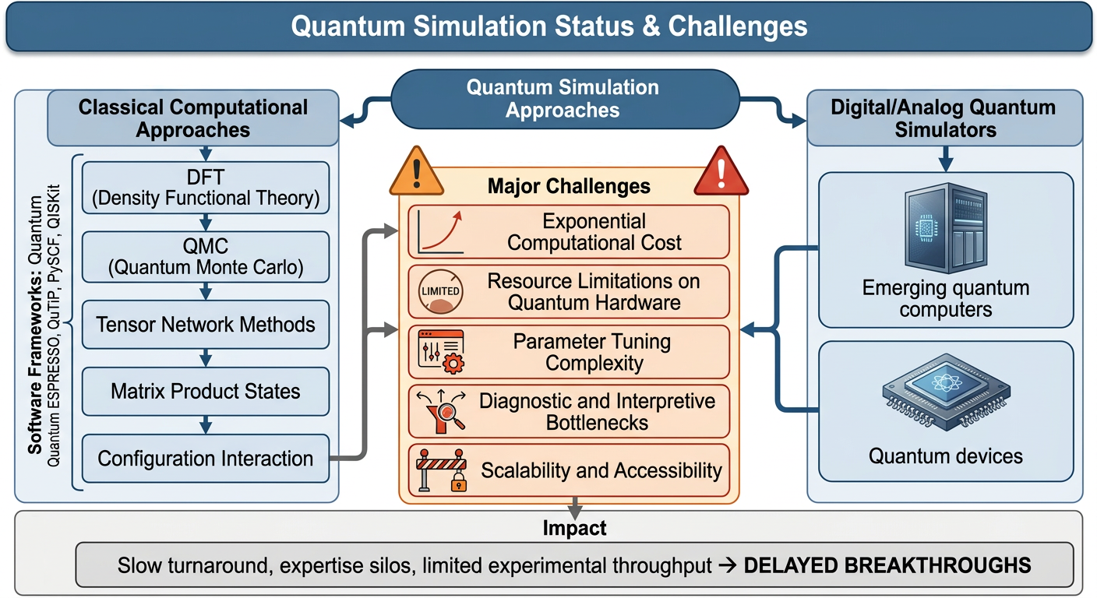
Figure 1: Quantum Simulation

Recent advancements in AI/ML can help alleviate these bottlenecks, particularly surrogate models based on Graph Neural Networks can potentially help approximate expensive simulations, guide parameter exploration, and accelerate discovery pipelines, especially by incorporating agentic AI into the workflows.

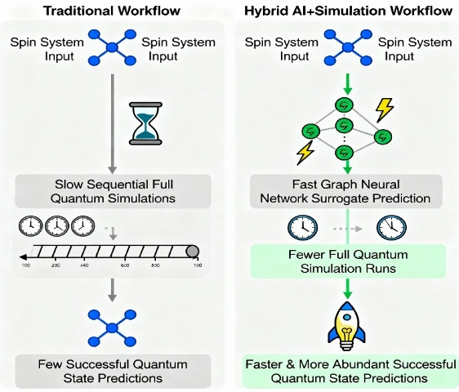
Figure 2: Workflow Comparison

9

Motivation

To boost scientific research with manual labour being applied to thinking and reasoning rather than the grunt work of calculating every possibility and discarding ones that do not fit. Experimentation requires expertise, plugging in values in the same equations doesn’t. The moment that machines and AI are used as they were intended, there will be growth of science.

LITERATURE REVIEW

Survey:
In quantum mechanics, the wavefunction(Ψ) tells us the complete characteristics and behaviour of a quantum system. For a large system containing many particles, this wavefunction is very difficult to computationally calculate.
This is where NNQS comes in. Neural Network Quantum State is an ML surrogate that becomes the model of the quantum state. Instead of calculating Ψ, our NN learns to approximate it.
The first paper that introduced this idea is the Carleo & Troyer (2017): “Solving the Quantum Many-Body Problem with Artificial Neural Networks”
Another paper describing how Agentic AI helps optimize scientific workflows is the “Müller et al. (2020): "Revolution of Scientific Workflows in the Agentic AI Era”. It shows how Agentic AI reduces manual effort and hence accelerates discovery.
My model applies both NN surrogates and agentic workflows directly to practical quantum simulation tasks(parameter selection, interpreting outputs, estimating results)

Review – Focus areas, Pros & Cons
Reference | Main Contribution | Pros (Carried Forward) | Cons (Minimized)
El Agente Q (LLM agent, 2025) | Automates quantum chemistry workflows via LLM conversations | Powerful automation, Multi-tool orchestration | LLM hallucinations, Complexity, Not robust for novices
ML Surrogates (Nature 2019) | Fast ML surrogate models for quantum properties | Fast predictions, ML generalizability | Not workflow-integrated, Less user-facing
Design Agents (RL, Innsbruck 2020) | RL agents for quantum experiment design | Creative, Autonomous experiment planning | Narrow use, Not an accessible UI
SpinQ Quantum AI Lab | Hardware/software quantum ML research advances | Cutting-edge algorithms, HW/SW co-design | Not designed for accessible interaction
PySCF (2018) | Open-source quantum chemistry simulation toolkit | Flexible, modular, academic support | Steep learning curve, not conversational
Quantum ESPRESSO (2017) | Density Functional Theory based quantum simulation software | High accuracy, broad material coverage | Slow simulation pipeline, command-line centric
Qiskit (2019) | General quantum computing toolkit for IBM Q systems | Cloud-ready, broad quantum algorithm support | Needs programming skill, limited parameter guidance
QuTiP (2012) | Quantum Toolbox in Python for dynamics/simulation | Easy quantum system setup, Python friendly | No integrated workflow builder, limited ML support
SmartChem (2019) | ML-driven retrosynthesis planning for chemistry | Predictive, ML integration, accessible UI | Focused on chemistry, not general quantum simulation
Google DeepMind Ferminet (2020) | Neural network model for electronic structure calculation | High surrogate accuracy for many-electron systems | Research-grade, not general user workflow
Quantum Surrogate Benchmarks (2023) | Systematic analysis of surrogate models for quantum data | Showed ML surrogates can learn quantum landscapes | Benchmark focus, no practical workflow integration
Table 1
Comparative Study of Literature
Reference /  Approach | Automation | Accessibility | Surrogate ML | Parameter Guidance | Output Interpretation | Workflow Integration | Scalability
El Agente Q (LLM agent, 2025) | Yes | Moderate | No | Partial | Yes | Multi-tool | Yes
ML Surrogates (Nature 2019) | No | Low | Yes | No | No | Poor | Yes
Design Agents (RL, Innsbruck) | Partial | Low | No | No | No | Narrow | Yes
SpinQ Quantum AI Lab | No | Low | Yes | No | No | Poor | Yes
PySCF, ESPRESSO, Qiskit, QuTiP | No | Moderate | Limited | No | No | Strong | Moderate
SmartChem | Yes | High | Yes | Yes | Partial | Moderate | Yes
Google Ferminet | No | Low | Yes | No | No | Poor | Yes
Quantum Surrogate Benchmarks | No | Low | Yes | No | No | Poor | Yes
Proposed Solution | Yes | High | Yes | Yes | Yes | Full | Yes
Table 2

Problem Statement
How can we harness state-of-the-art AI techniques to model and accelerate quantum simulations, providing smart guidance and refined scenario selection, to democratize access, reduce computational cost, and transform the speed and scope of scientific discovery in quantum mechanics?
Quantum simulation is a vital research tool but remains inaccessible to many due to complexity, resource constraints, and a lack of user-centered guidance. The absence of automated parameter selection, real-time diagnostics, and fast prediction via ML surrogates means that both experts and newcomers experience slow, inefficient workflows, limited explorative capabilities, and a steep learning curve. There exists a critical need for an integrated, AI-powered assistant that streamlines the simulation workflow, democratizes access, and accelerates quantum discovery.

Objectives
- Demonstrating power of AI/ML in optimization of quantum simulations by reducing computational cost.
- Integrating an agentic AI to convert scientific workflows into conversational interactions for scientists.
- Allowing students or non-experts to run quantum simulations without in depth numerical or coding knowledge.
- Creating a blueprint for future agentic AI assisted scientific workflows.

Methodology and Framework
Solution
This paper provides a way to revolutionize quantum simulation workflows by integrating AI/ML in two key areas:
12
- Surrogate Modelling of Quantum Simulations
Rather than running calculations and simulations for every quantum system or parameter scenario, which may lead to wasted computations, ML surrogates based on neural architectures like Graph Neural Networks(GNN) can be leveraged.
Surrogate models can rapidly predict quantum properties and solutions in new scenarios and is trained on pre-existing sets of experimental or simulated results.
This can help in screening candidates(e.g., for materials or molecules) by allowing workflows to only prioritize simulations for promising subsets.
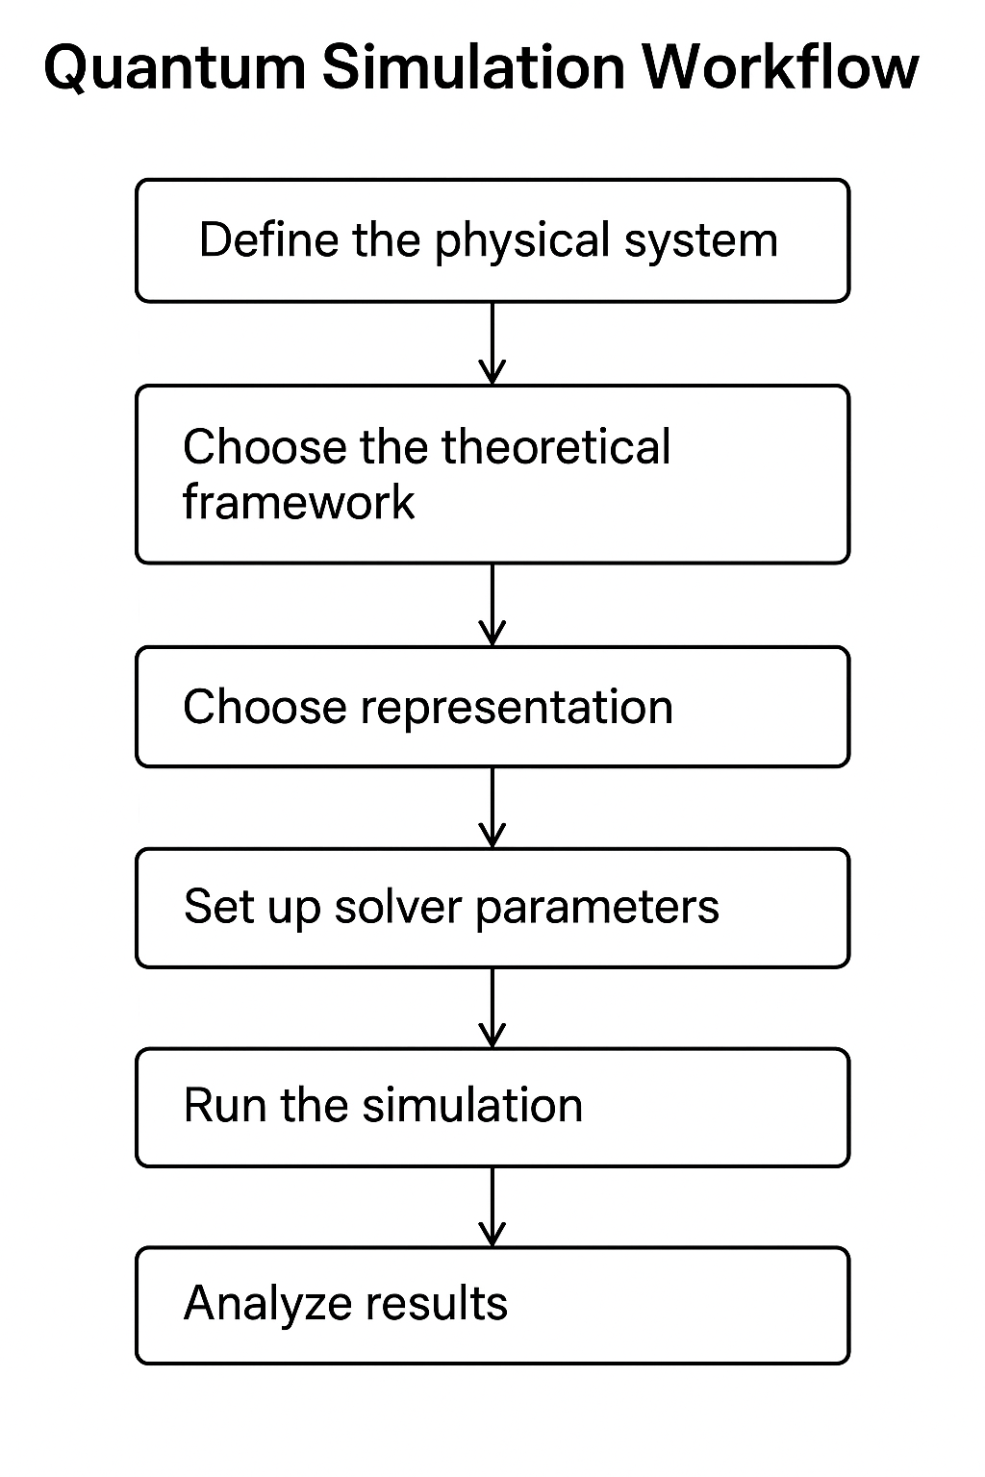
Figure 3: Simulation Workflow

- Agentic AI for end-to-end Quantum Simulation
Achieving a truly transformative quantum simulation workflow requires integration of parameter selection and surrogate outcomes that decide for or against simulation into a coherent, user-friendly platform. This paper suggests the orchestration of an agentic AI, specifically Salesforce Agentforce, to build a conversational, automated agent to make the workflow accessible.
Here, Salesforce Agentforce acts as the ‘brain’ of the assistant, orchestrating user interactions, ML surrogate calls whose outcomes determine whether backend simulation tasks are required and interpreting the results of these processes.
Key Capabilities:
13
  - Users start simulations in their respective quantum problem space
  - The agent triggers ML surrogates with multiple sets of simulation parameters
  - ML surrogates are invoked for instant predictions, rapidly narrowing down feasible or interesting parameter sets and flagging scenarios for detailed quantum calculation.
  - Once the optimal scenario is identified, the agent triggers full-physics quantum simulations via tools such as QuTiP or Qiskit, tracking execution and collecting comprehensive results.
  - Post-simulation, the agent parses and interprets results.

System Architechture
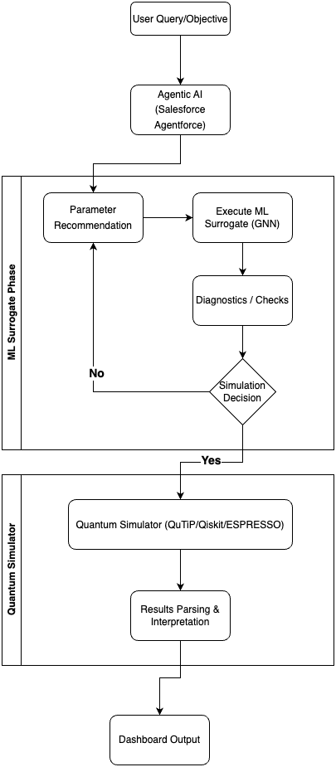
Figure 4: End-to-End Workflow
14
Detailed Design Methodologies
The proposed methodology follows a controlled and iterative workflow spanning agentic orchestration, machine-learning-based surrogate modelling, and traditional quantum simulation.
The objective is to augment the standard scientific quantum simulators with a rich decisioning and optimizing model that provides a refined and more higher probability parameter and configuration subset that helps reduce outliers and improves speed and accuracy of processing and also provides a structure to analyse and interpret outcomes.
At a high level, this system starts with user-defined scientific objective that fed to an AI agent which then analyses and identifies the relevant simulation pathway and routes the task through either a fast surrogate estimate or a higher-fidelity quantum solver depending on the diagnostic outcome.

1. Agentic intake
The process begins with the scientific objective expressed in natural language. The agentic layer translates this into a structured workflow by identifying the simulation type, the expected outputs, and the key parameter groups that must be evaluated.

2. Surrogate-guided parameter refinement
The next step is using a surrogate model for parameter refinement. The surrogate model is used for evaluating parameter choices and combinations to identify the most probable subset of choices that can then be fed into the quantum simulation model for further scientific analysis and decisioning.
This step helps reduce the problem space for the subsequent stimulation activities thus providing critical time saving and faster outcomes compared to traditional brute-force simulation approaches where the entire problem space is evaluated.

3. Diagnostics and decision control
The next step is diagnostics and decisioning that help identify inconsistent parameter configurations and determination of whether to rerun the surrogate model to generate a new set of options or invoke the quantum simulator with the configuration options generated from the surrogate model. This step provides a control mechanism in the workflow before the expensive quantum simulation is initiated.
Quantum simulation and authoritative validation
The quantum simulation is the final evaluation phase that will provide the final outcomes and scientific results for the provided problem statement. The quantum simulator is the trusted

15
backend that validates the surrogate-guided selection. The helps preserve the rigor of traditional quantum computation. This hybrid structure of a surrogate modelled quantum simulation leverages the computational advancements in machine learning to accelerate exploration, while continuing to base scientific analysis on domain-specific quantum simulator for scientific outcomes.

5. Result interpretation and reporting
The final phase of the workflow is output interpretation. The simulation results are parsed and summarized. The system not only provides the raw numerical values but also provides an analysis of the results and how they map to original problem statement. The dashboard then presents the final output allowing the workflow to serve both researchers and learners. This reporting layer thus help turns a complex scientific computation into a practical and reusable research aid.

Workflow Interpretation
The diagram therefore represents a two-stage computational strategy wrapped inside an agentic control framework. The initial stages leverage AI for planning, parameter recommendation, and surrogate inference, while the later stages provide the scientific rigor using quantum simulation and result presentation. Conceptually, this separation reflects the project’s philosophy: first narrow the problem intelligently, then apply the scientific approach to problem solving where it matters most.

Work done
Result and discussion
The workflow design successfully connects user intent, surrogate prediction, diagnostics, and quantum simulation into one clear pipeline. The surrogate stage helps narrow down simulation scenarios before costly computation is used.
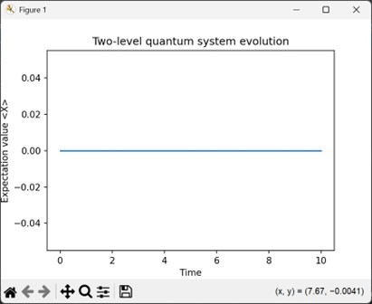
Figure 5: Simulation
16
The diagnostic step adds a useful checkpoint for catching poor parameter choices early.
The overall structure shows that AI can improve both speed and usability in quantum simulation research.

Conclusion
Surrogate models help in parameter screening by providing predictions based on given thresholds.
Agentic AI simplifies complex scientific workflows by guiding surrogate predic- tions and simulations, and interpreting the results, instead of everything being done manually

Future Work
Research Directions:
Beyond the current approach, there are multiple further research avenues - both expanding the system intelligence implementing active learning loops and expanding the domains of use; as well as industrialized the current solution into a research-platform grade solution that can be scaled across multi-users and use cases.
Active Learning Loops using multi-scale simulation and uncertainty quantification: Implement ML models that suggest optimal parameter sets for simulation based on uncertainty quantification and exploration-exploitation balance. Com- bine fast ML surrogates with high-fidelity DFT/Quantum ESPRESSO runs, automatically selecting the right fidelity for each scenario. Add Bayesian neural networks or ensemble methods to surrogate models for reliable confidence intervals on predictions.
Domain Expansion: Adapt the agentic workflow to other scientific domains (materials discovery, protein folding, quantum chemistry reaction prediction).
Production and Scalability:
Multi-User Support: Add user authentication, simulation queuing, and result persistence with database integration.
Performance Benchmarks: Quantify speedup vs traditional workflows through controlled experiments across molecular libraries.

17
Outcome
Research Paper, titled “AI-Assisted Quantum Simulation & Modelling with Salesforce Agentforce” selected for Peer Review for publication in Scopus Indexed Journal through MQUBIT Conference, March 2026.

References
[1]Bensoussan, A., Chachkarova, E., Even-Mendoza, K., Fortz, S., and Lenihan, C. (2025). AccelerQ: Accelerating quantum eigensolvers with machine learning on quantum simulators. Proceedings of the ACM on Programming Languages, 9(OOPSLA2), Article 354, 1–31. https://doi.org/10.1145/3763132
[2]Zou, Y., Cheng, A. H., Aldossary, A., Bai, J., Leong, S. X., Campos-Gonzalez- Angulo, J. A., ... and Aspuru-Guzik, A. (2025). El Agente: An autonomous agent for quantum chemistry. Matter, 8(7).
[3]https://www.spinquanta.com/news-detail/spinq-quantum-artificial-intelligence-lab- research-project-overview
[4]Carleo, G., and Troyer, M. (2017). Solving the quantum many-body problem with artificial neural networks. Science, 355(6325), 602–606. https://doi.org/10.1126/science.aag2302
[5]Shin, W., Souza, R., Rosendo, D., Suter, F., Wang, F., Balaprakash, P., and da Silva, R. F. (2025). The (R)evolution of scientific workflows in the agentic AI era: Towards autonomous science. In Proceedings of the 20th Workshop on Workflows in Support of Large-Scale Science (WORKS ’25) (pp. 2305–2316). Association for Computing Machinery. https://doi.org/10.1145/3731599.3767580

18

